


POLICY FOR ADMISSION TO:

Presentation Community College, Terenure Park, Dublin 6W

A decision on an application for admission will be based on the implementation of this Policy, the information set out in the annual Admission Notice of the school and the information provided by the Applicant in the application for admission, once received before the closing date set out in the annual Admission Notice. The Principal of Presentation Community College is responsible for the implementation of this Admission Policy.

Introduction to Presentation Community College

Presentation Community College is a state, co-educational, multi-denominational post-primary school under the patronage of the City of Dublin ETB, underpinned by the core values of:

- Excellence in Education
- Care
- Respect
- Equality
- Community

Mission Statement:
We strive to be a caring, vibrant school where all are valued and encouraged to learn and explore, where people feel they belong and that they are challenged and supported to perform to the best of their abilities.

Geographical Location:
Presentation Community College is located in Terenure Park, Terenure, Dublin 6W.
Presentation Community College aims to use all of its resources be they physical, human, technological or other to help all in the school community to perform to their best. We are committed to a mix of learning methodologies including digital.

Presentation Community College offers the Junior Cycle Programme (1st, 2nd and 3rd Year) and Senior Cycle which comprises Transition Year (4th Year), 5th year and 6th Year.

The extra-curricular and co-curricular activities are wide and varied and include sport disciplines, arts, humanities, music amongst others.

We are committed to being a Green School and have secured Green Flags.

Presentation Community College has strong links to the community around us and this is shown through our engagement with elderly residents, primary schools, businesses and other community partners on an annual basis.

TABLE OF CONTENTS

PART A – General Information for All Applicants
- Glossary of terms
- Admission Statement
- Legal Framework
- General Admission Provisions (for all Applicants)

PART B - Information for Specific Categories of Applicants
- Application to the First-Year Group
- Application to All Year Groups Other Than First-Year
- Application to the Special Class

PART A - General Information for All Applicants
- Glossary of terms
- Admission Statement
- Legal Framework
- General Admission Provisions (for all Applicants)

- GLOSSARY OF TERMS

‘Applicant’ means the parent / guardian of a Student, or, in the case of a Student who has reached the age of 18 years, the Student, who has made an application for admission to Presentation Community College.

‘Student’ means the person in respect of whom the application is being made. All uses of the word throughout this Policy therefore imply ‘prospective’ as part of the interpretation. That is, the use of the word ‘Student’ does not mean that an application or acceptance of offer makes him/her a student of Presentation Community College; a person is only regarded as a student of Presentation Community College once he/she is enrolled on his/her first day of attendance. It does not include a person who was formerly enrolled in the school and was permanently excluded from the school, or who left the school after being recommended for expulsion by the Board of Management.

‘Enrolled’ means attending the school as a registered student, in line with Section 20(2) of the Education (Welfare) Act 2000.

‘Gender’, in line with the definition of “the gender ground” in the Equal Status Act 2000, is such that “one is male and the other is female”. This does not prejudice any Student who is Intersex or identifies as Androgynous/Androgyne, Bigender, Demigender, Gender Fluid, Genderqueer, Multigender, Neutrois, Non-binary, Transgender, Transsexual or otherwise.

‘Catchment Area’ refers to the designated residential area determined by the Board of Management of Presentation Community College in respect of the person on whose behalf the application is being made. The catchment area for Presentation Community College is defined as per the map attached. The boundary roads on the map are Wainsfort Road, Kimmage Road Lower, Kenilworth Park, Rathgar Avenue, Orwell Road, Braemor Park, Braemor Road, Dodder Park Road, Springfield Avenue, Templeville Road (ending at the roundabout moving back to Wainsfort Road). This map can be found on our website. Any queries regarding your residence in relation to the catchment area can be emailed to info@pcc.cdetb.ie.

‘Catchment Area for the Special Classes’ refers to the designated residential area determined by the Board of Management of Presentation Community College in respect of the person on whose behalf the application is being made to the Special Class. The catchment area for Presentation Community College Sepcial Class is defined as per the map attached. The boundary roads on the map are Wainsfort Road, Kimmage Road Lower, Kenilworth Park, Rathgar Avenue, Orwell Road, Braemor Park, Braemor Road, Dodder Park Road, Springfield Avenue, Templeville Road (ending at the roundabout moving back to Wainsfort Road). This map can be found on our website. Any queries regarding your residence in relation to the catchment area can be emailed to info@pcc.cdetb.ie.

‘Parent’ has the same meaning as in the Education Act 1998 and includes a guardian appointed under the Guardianship of Children Acts, 1964 to 1997.

‘Feeder Primary Schools’ refers to the primary schools of preference for application to Presentation Community College. The feeder primary schools for Presentation Community College are:
- Presentation Primary School, Terenure
- St. Joseph’s Boys School, Terenure
- Harold’s Cross Primary School

‘Sibling’ For the purpose of the selection criterion relating to the student having a sibling who previously attended the school, ‘Sibling’ refers to full siblings, half siblings, foster siblings, step siblings and students who reside in the same household. [Note: the wider definition of sibling in the second of the two paragraphs immediately above is for the purpose of facilitating families who are required to do more than one drop off and/or collection to/from the school.]

‘First-Year’ means the intake group of Students for the most junior class or year in a school.

‘Special Class’ means a class that has, with the approval of the Minister of Education, been established by a school to provide an education exclusively for Students with a category or categories of special educational needs, specified by the Minister of Education.
Presentation Community College has two Special Classes, established to cater for special educational needs of students with Autism/Autism Spectrum Disorders.

‘Relevant Report’, as advised by the Department of Education and the National Council for Special Education (NCSE), means a written report, based on an assessment by a relevant professional, which:
(a) provides detailed evidence of the Student’s needs,
(b) confirms that those needs constitute complex/severe educational needs which arise from a named diagnosis relating to the Student, and
(c) makes a recommendation for a Special Class placement for the Student on the basis of his/her complex/severe educational needs arising from said diagnosis.
The relevant professional may include an educational psychologist, psychologist, other relevant health professionals, HSE disability services or HSE multi-disciplinary team staff, in line with guidance issued by the NCSE on this point.

- ADMISSION STATEMENT

City of Dublin ETB schools are state, co-educational, multi-denominational schools underpinned by the core values of:

- Excellence in Education;
- Care;
- Equality;
- Community and
- Respect.

As the state provider of education, the ETB sector defines a ‘multi-denominational’ school in the following way:
In City of Dublin ETB schools, all students are given equal opportunities for enrolment in line with the Education (Admissions to School) Act 2018. Once enrolled, our schools strive to provide all students with equal opportunities to engage with the curriculum and school life. In all aspects of school life all members of our school communities are treated equitably regardless of their race, gender, religion/belief, age, family status, civil status, membership of the Traveller community, sexual orientation, ability or socio-economic status.
Our schools provide a safe physical and social environment that reinforces a sense of belonging to the school community and wider society. They strive to enable every student to realise their full potential regardless of any aspect of their identity or background. Our schools promote a fully inclusive education that recognises the plurality of identities, beliefs and values held by students, parents and staff. We prepare open-minded, culturally sensitive and responsible citizens with a strong sense of shared values.

In City of Dublin ETB schools, students of all religions and beliefs are treated equally. The school environment and activities do not privilege any particular group over another whilst at the same time acknowledging and facilitating students of all religions and beliefs.

Accordingly, Presentation Community College shall not discriminate in its admission of a Student based on the following grounds:

- Gender of the Student or Applicant. However, where a school admits students of one gender only, it is not discriminatory to refuse to admit Students not of that gender;
- Civil status of the Student or Applicant;
- Family status of the Student or Applicant;
- Sexual orientation of the Student or Applicant;
- Religion of the Student or Applicant;
- Disability of the Student or Applicant;
- Race of the Student or Applicant;
- The Student’s or Applicant’s membership of the Traveller community;
- Special educational needs of the Student or Applicant. [However, where the school provides education exclusively for a category or categories of special educational need(s) in a special class, it is not discriminatory to refuse to admit to that class a student who does not have the specified special educational need(s).

Presentation Community College shall not charge fees or payments or seek contributions as a condition of admission or continued enrolment of a Student.

- LEGAL FRAMEWORK

City of Dublin ETB was established under the Education and Training Board Act 2013 which sets out the functions of all ETBs, including to establish and maintain recognised schools, centres for education and education and training facilities in each ETB’s functional area.

The board of management of Presentation Community College is a committee established under section 44 of the Education and Training Board Act 2013 and also constitutes a board of management within the meaning of the Education Act 1998.

The Education (Admissions to Schools) Act 2018 and the Education (Welfare) Act 2000 place a duty on all recognised schools to prepare and publish an Admission Policy.

The Education Act, 1998 provides for an appeal process in the event of a refusal to enrol. The appeal process is set out in section 5.4 in respect of applications made to the First-Year group and in section 6.4 in respect of applications made to all year other than the First-Year group.

Section 62(7)(n) of the Education Act 1998 requires each school to set out in its Admission Policy the arrangements it has in place where a parent, or student over 18 years of age, requests that the student opt-out of religious instruction.

Presentation Community College offers religious education in all year groups as it promotes the holistic development of students and can contribute positively to their wellbeing in line with the principles of the Junior Cycle and Senior Cycle Frameworks. It facilitates the intellectual, social, emotional, spiritual, values and moral development of students and encourages respect for all members of our school communities. In addition, religious education supports the ‘multidenominational’ aspect of our school’s ethos as it provides opportunities for students in engage with questions around their own religious or non-religious beliefs and those of their peers.
It is important to understand that our school does not provide ‘religious instruction’ and therefore the need to opt-out does not arise in this school. It is also important to understand the distinction between ‘religious instruction’ and ‘religious education’:
- Religious instruction is a term used in Ireland to indicate instruction in accordance with the rites, practices and teachings of a particular religion or denomination for pupils of that religious tradition. Religious Instruction may be provided in a denominational school setting.
- Religious education is open to all pupils regardless of their commitment to any particular religion or worldview. It seeks to contribute to the spiritual and moral development of all students equally.
As ETB schools are ‘multi-denominational’, Presentation Community College supports the provision of religious education that caters for all students regardless of their religious or nonreligious beliefs and therefore does not provide religious instruction in one particular religion or belief.
However, as per Section 30(2)(e) of the Education Act (1998), Presentation Community College recognises the right of parents, or students over the age of 18, attending publicly-funded schools to withdraw from any subject contrary to their conscience, including religious education.
Parents or students over the age of 18 who wish to opt-out of religious education must make a written submission to the principal in the first instance. The submission should outline reasons why the opt-out is being requested. The principal will then arrange to meet with the parent(s) or student over the age of 18 to discuss the request. If after that meeting the parent or student over the age of 18 still wishes to opt out of religious education, the school will facilitate this in the best way possible in the school that does not create resourcing or financial implications for CDETB or the DES. Please note, 62(7)(n) of the Education Act 1998, the school day cannot be shortened for the student as a result of opting out of religious instruction.

- GENERAL ADMISSION PROVISIONS

A decision on an application for admission shall be based on:
- the implementation of this Admission Policy;
- the annual admission notice of the school; and
- information provided by the Applicant in the application for admission.

In processing an application, Presentation Community College shall not consider:

- The payment of fees or contributions to the school;

- A Student’s academic ability, skills or aptitude unless:
It is necessary to ascertain whether or not the student has the category of special educational needs concerned for admission to a school approved by the Minister of Education providing education exclusively to students with a specified category of special educational needs or a special class;

- The occupation, financial status, academic ability, skills or aptitude of a Student’s Parent(s);

- A requirement that a Student or his or her Parent(s), attend an interview, open day or other meeting as a condition of admission;

- A Student’s connection to the school due to a member of his or her family attending or having previously attended the school, unless the connection is a sibling of the Student concerned attending, or having attended, the school, or a parent having previously attended the school. However, the maximum number of places filled by this criterion does not exceed 25% of the available places as set out in the school’s admission notice.

- The date and time on which an application for admission was received by the school as long as it is received during the period specified for receiving applications set out in the annual Admissions Notice for that academic year.

- Presentation Community College will consider the offer of a place to every Student seeking admission to the school, unless one of the following applies:

- The Parent fails to confirm in writing that s/he accepts the Student Code of Behaviour and he/she shall make all reasonable efforts to ensure compliance with such code by the Student;
- The Student seeking admission to a Special Class in the school does not have the category of special educational needs specified by the Minister of Education in respect of that class.

Where Presentation Community College considers an application, each Student shall receive a place, unless the school is oversubscribed, in which case, selection criteria will be applied to each application.

Section 5 of this Policy addresses the selection criteria and other matters related to the admission provisions for the first-year group.

Section 6 of this Policy addresses the selection criteria and other matters related to the admission provisions for all year groups other than first-year.

Section 7 of this Policy addresses the selection criteria and other matters related to the admission provisions for the Special Class.

PART B - Information for Specific Categories of Applicants
- Application to the First-Year Group
- Application to All Year Groups Other Than First-Year
- Application to the Special Class

- APPLICATION TO THE FIRST-YEAR GROUP

Admission Provisions (First-Year group)

5.1.1. Oversubscription
5.1.2. Selection criteria in order of priority
5.1.3. Selection process
5.1.4. Late Applications
5.1.5. Second/third-round offers of a place
5.1.6. Acceptance of a place
5.1.7. Refusal
5.1.8. Withdrawal of an offer
5.1.9. Appeals

Appeals

5.2.1. Appeal where refusal was due to oversubscription
5.2.2. Appeal where refusal was for a reason other than oversubscription
5.2.3. Basis for a review by the Board of Management

5.1 ADMISSION PROVISIONS (FIRST YEAR GROUP)

In the event that Presentation Community College is not oversubscribed, all Students will be offered a school place, subject to sections 4.7, 4.8.
A Student applying for the First-Year group but seeking admission to the Special Class should see Section 7 of the Admission Policy. If the Student is also applying for a place in the mainstream First Year group in the event of an unsuccessful application to the Special class, this section 5 is also applicable.

Incomplete applications received by the school will not be processed under this policy.

5.1.1 Oversubscription

When the number of applications exceeds the number of places available, the published selection criteria as set out at section 5.1.2 below will apply and a waiting list shall be compiled which shall remain valid for the school year in respect of which the applications are made. Where Presentation Community College is in a position to offer further school places that become available for and during the 2026/2027 school year, places will be offered in accordance with the order of priority in which Students have been placed on the waiting list, subject to the provisions of Section 7.1.1 regarding the Special Class.

For the avoidance of doubt, if a student does not receive a place in the school for a given academic year, but s/he wishes to be considered for admission to the same year group in the following academic year, a new application must be made on behalf of that Student during the dates specified by the school as being the period when it will accept applications to all year groups other than First-Year.

Where an application is made on behalf of a Student, for both the Special Class and the mainstream year group, and his/her application for one but not both is successful, he/she will remain in the same position on the waiting list for the group to which she/he was not successful, regardless of whether the Applicant accepts the place in the group to which the student was successful.

Where the school is oversubscribed, any selection criteria that are not included in this Admission
Policy shall not be considered in determining whether or not a Student is admitted to the school.

5.1.2 Selection criteria in order of priority

Presentation Community College will apply the following criteria for admission to the first-year group:

- If the Student will have attained at least 12 years of age by 31st January of the academic year to which s/he is applying to be enrolled in first year and resides in the catchment area (as defined above and by the attached map);

- If the Student will have attained at least 12 years of age by 31st January of the academic year to which s/he is applying to be enrolled to first year and if the Student has siblings currently enrolled in the school;

- If the Student will have attained at least 12 years of age by 31st January of the academic year to which s/he is applying to be enrolled to first year and whether the Student attended Presentation Primary School;

- If the Student will have attained at least 12 years of age by 31st January of the academic year to which s/he is applying to be enrolled to first year and whether the Student attended St. Joseph’s Primary School;

- If the Student will have attained at least 12 years of age by 31st January of the academic year to which s/he is applying to be enrolled to first year whether the Student attended Harold’s Cross Primary School;

- If the Student will have attained at least 12 years of age by 31st January of the academic year to which s/he is applying to be enrolled to first year and if the Student has siblings who were previously enrolled in the school;

- If the Student will have attained at least 12 years of age by 31st January of the academic year to which s/he is applying to be enrolled in first year and if the Student had a parent who previously attended the school (to a maximum of 25% of the places available);

- All other students who will have attained at least 12 years of age by 31st January of the academic year to which s/he is applying to be enrolled in first year.

5.1.3 Selection process

Presentation Community College will apply the selection process as follows:

Applications are considered against the published selection criteria. Places will be offered in the first instance to those who meet the first criterion. Subsequently, where the relevant year group still has places available, the remaining Applicants are considered in light of the second criterion and those Applicants who meet this criterion will be offered a place within the relevant year group. This process is continuously carried out against all selection criteria until all available places have been offered and accepted.

Where two or more applications are tied in the foregoing selection process, Presentation Community College will apply a random lottery to assign any available places in the relevant year group, or on the waiting list, to those applications.
N.B. The number of places available in a year group is subject to reduction in the event that a placement(s) in the Special Class is/are given to Student(s) from that year group, i.e the selection process for the Special Class will be completed before the selection process for the mainstream year group, and the number of Students who are offered a place in the Special Class will be the number by which the places in the relevant mainstream year group(s) are reduced.

5.1.4 Late applications

An application received by Presentation Community College after the closing date published by the school, and set out in the Admission Notice, is considered a late application for the purposes of this Admission Policy.

Where the relevant year group is oversubscribed and receives a late application for admission, same will receive a place on the waiting list beneath Applicants whose applications were received by Presentation Community College before the closing date for applications. Such applications will be placed on the waiting list in accordance with the date and time they were received by Presentation Community College and subsequently Presentation Community College’s selection criteria will be applied in accordance with this Policy.

Where Presentation Community College is not oversubscribed and it receives a late application, the Student seeking admission will receive an offer of a place within Presentation Community College, subject to sections 4.7, 4.8. For the avoidance of doubt, selection criteria are not relevant to and will not be applied to late applications.

Where the relevant year group is not oversubscribed, i.e. there is no waiting list, and it receives a late application, the Student seeking admission will receive an offer of a place within the relevant year group, subject to sections 4.7, 4.8, and the same process as applies to Applicants whose applications were received before the closing date will be applied, i.e. an Acceptance Form will be issued to the Applicant for completion and return to the school within two weeks of issue.

5.1.5 Second/third-round offers of a place

Where a Student is in receipt of an offer of a place within the relevant year group but does not accept the offer, or fails to accept within the specified time period, or the school withdraws the offer in line with the relevant provisions of this Policy, the place will be offered to the next Student on the waiting list in a second-round of offers. This process will continue throughout third and fourth rounds etc. until all places within the relevant year group have been filled.

5.1.6 Acceptance of a place

If the Student in respect of whom the application is made is offered a place, the Applicant will be issued with an Acceptance Form by the school. The Applicant shall indicate acceptance of an offer by fully completing and returning the Acceptance Form by the date set out in the School Admission Notice, or within two weeks of issuing by the school if it is a late application or if it is a second/third round offer. This includes indicating whether or not s/he has applied for and is awaiting confirmation of an offer of admission from another school.

Failure to fully complete and return the Acceptance Form to the school by the date set out in the School Admission Notice, or within two weeks of issuing by the school if it is a late application or if it is a second/third-round offer, may result in withdrawal of an offer, as set out below.

5.1.7 Refusal

Where a Student in respect of whom an application is being sought has not been offered a school place, the Applicant will be provided in writing with:

5.1.7.1. The reasons that the Student was not offered a place in Presentation Community College;

5.1.7.2. Details of the Student’s ranking against the published selection criteria, if the year group to which they Applicant is applying is oversubscribed;

5.1.7.3. Details of the Student’s place on the waiting list, if applicable, and

5.1.7.4. Details of the Applicant’s right to appeal the decision.

In addition to the conditions for consideration of an application as set out at 4.7 and 4.8, an offer of admission may not be made where:

5.1.7.5. The information contained in the application is false or misleading in a material respect.

5.1.8 Withdrawal of an offer

An offer of admission may be withdrawn where:

5.1.8.1. The information contained in the application is false or misleading in a
material respect, or

5.1.8.2. The Applicant fails to confirm acceptance of an offer of admission on or
before the date set out in the annual admission notice of the school for the academic year for which the s/he is applying, or in the case of a late application, or second/third-round offer, within 2 weeks, or

5.1.8.3. An Applicant has not indicated:
- whether or not s/he has applied for and is awaiting confirmation of an offer from another school(s) and if so, the details of the school(s); and
- whether or not or s/he has accepted an offer of admission from another school(s) and if so, the details of the offer(s).

If an offer of a place is withdrawn by the school, the Student on whose behalf the application was made shall lose his/her place on the admission list or waiting list for that academic year (and shall not be placed on a waiting list). If the Applicant still desires a place for that academic year, a new application must be made for the same academic year on behalf of that Student and shall be treated as a late application in line with section 5.1.4 above.

5.1.9 Appeals

For information relating to an Applicant’s right to appeal a decision of Presentation Community College regarding admission to the First-Year group, see section 5.3.

5.2. APPEALS

5.2.1 Appeal where refusal was due to oversubscription

An Applicant who was refused admission because the school is oversubscribed and who wishes to appeal this decision must first request a review by the Board of Management in writing, via a ‘BOMR 1’ form, available from the school office and at https://www.gov.ie/en/publication/8248c-appeals-in-relation-to-refusal-to-admit-a-student-due-to-a-school-being-oversubscribed/#how-to-seek-a-review-by-the-board-of-management, for it to be reviewed by the board of management of Presentation Community College. Such a review must be sought by the Applicant within 21 calendar days of the school’s decision to refuse to admit. However, if a different time period for the bringing of such an appeal is specified by the Minister for Education after the publication of this Policy, same shall apply instead. Completed ‘BOMR 1’ forms should be submitted to the school office or online by emailing info@pcc.cdetb.ie.

If an Applicant is not satisfied with the decision of the board of management, or the board of management is not in a position to review the decision to refuse admission, the Applicant may apply to bring an appeal to an appeals committee established by the Minister for Education under section 29A of the Education Act 1998. Appeals must be made in writing on ‘Section 29 appeal form’ available at https://www.gov.ie/en/publication/8248c-appeals-in-relation-to-refusal-to-admit-a-student-due-to-a-school-being-oversubscribed/#how-to-appeal-if-a-child-has-been-refused-admission-because-the-school-is-full and submitted to the Section 29 appeals administration unit in the Department of Education or the appeal can be submitted online by uploading the required documentation at https://www.section29appeals.gov.ie. As per the Department of ‘Education’s Procedures for Hearing and Determining Appeals under Section 29’, such an appeal must not be brought until the Applicant has received correspondence from the board of management in relation to the review, or until 42 calendar days have passed since the date of initial refusal, whichever is earlier, and an appeal may not be brought later than 63 calendar days after the initial decision to refuse admission.

5.2.2 Appeal where refusal was for a reason other than oversubscription:
An Applicant who was refused admission to Presentation Community College for a reason other than the school being oversubscribed and who wishes to appeal this decision may first choose to request a review by the board of management via a ‘BOMR 1’ form, available from the school office and at https://www.gov.ie/en/publication/8248c-appeals-in-relation-to-refusal-to-admit-a-student-due-to-a-school-being-oversubscribed/#how-to-seek-a-review-by-the-board-of-management, for it to be reviewed by the board of management of Presentation Community College. Such a review must be sought by the Applicant within 21 calendar days of the school’s decision to refuse to admit. However, if a different time period for the bringing of such an appeal is specified by the Minister for Education after the publication of this Policy, same shall apply instead. Completed ‘BOMR 1’ forms should be submitted to the school office or online by emailing info@pcc.cdetb.ie. (An Applicant may withdraw a request for review at any time prior to the conclusion of the review by notifying the board of management in writing to that effect).

Alternatively, s/he may choose to apply to bring an appeal to an appeals committee established by the Minister for Education under section 29A of the Education Act 1998. Appeals must be made in writing, on a Section 29 Appeal Application Form at https://www.gov.ie/en/publication/31c4f-appeals-in-relation-to-refusal-to-admit-a-student-for-a-reason-other-than-the-school-being-oversubscribed/#how-to-appeal-if-my-child-has-been-refused-admission-and-the-school-has-places-available and submitted to the Section 29 appeals administration unit in the Department of Education or the appeal can be submitted online by uploading the required documentation at https://www.section29appeals.gov.ie/. As per the Department of Education’s ‘Procedures for Hearing Determining Appeals under Section 29’ such an appeal may not be brought later than 63 calendar days after the initial decision to refuse admission.

If an Applicant who seeks a review by the board of management is not satisfied with the decision of the board of management, that Applicant may also apply to bring an appeal to an appeals committee established by the Minister for Education under section 29A of the Education Act 1998, as outlined in the immediately preceding paragraph.

5.2.3 Basis for Review
As required by section 29C(2) of the Education Act 1998, any request for the board of management to review a decision of the school to refuse admission must be based on the implementation of this admission policy, the content of the school’s Admission Notice and also set out the grounds of the request to review the decision.

- APPLICATION TO ALL YEAR GROUPS OTHER THAN FIRST-YEAR

6.1 Admission Provisions (other than First-Year)
6.1.1. Oversubscription
6.1.2. Selection criteria in order of priority
6.1.3. Selection process
6.1.4. Late Applications
6.1.5. Second/third-round offers of a place
6.1.6. Acceptance of a place
6.1.7. Refusal
6.1.8. Withdrawal of an offer
6.1.9. Appeals

6.2 Appeals
6.2.1. Appeal where refusal was due to oversubscription
6.2.2. Appeal where refusal was for a reason other than oversubscription
6.2.3. Basis for Review by the Board of Management

6.1 ADMISSION PROVISIONS (OTHER THAN FIRST-YEAR)

In the event that Presentation Community College is not oversubscribed, all Students will be offered a school place, subject to sections 4.7, 4.8.

A Student applying for admission to a year group other than First Year but seeking admission to the Special Class should see section 7 of this Admission Policy. If the Student is also applying for a place in the mainstream year group other than First Year in the event of an unsuccessful application to the Special Class, this section 6 is also applicable.

Incomplete applications received by the school will not be processed under this policy.

6.1.1 Oversubscription
When the number of applications exceeds the number of places available, the published selection criteria as set out at section 6.1.2 below will apply and a waiting list shall be compiled which shall remain valid only for the school year in respect of which the applications are made. Where Presentation Community College is in a position to offer further school places that become available for and during that academic year, places will be offered in accordance with the order of priority in which Students have been placed on the waiting list, subject to the provisions of section 7.1.1 regarding the Special Class.

For the avoidance of doubt, if a Student does not receive a place in the school for a given academic year, but s/he wishes to be considered for admission in the following academic year, a new application must be made on behalf of that Student during the dates specified by the school as being the period when it will accept applications to all years other than the First Year Group.

Where an application is made on behalf of a Student for both the Special Class and a mainstream year group, and his/her application for one but not both is successful, s/he will remain in the same position on the waiting list for the group to which s/he was not successful, regardless of whether the Applicant accepts the place in the group to which the Student was successful.

Where the school is oversubscribed, any selection criteria that are not included in this Admission Policy shall not be considered in determining whether or not a Student is admitted to the school.

Where the Transition Year Programme in Presentation Community College is oversubscribed, a Student applying for admission to such programme, will, subject to this policy, be placed on the appropriate waiting list already compiled (annually) by the school, which list will contain the names of students enrolled in the school who have been placed on an internal waiting list for this programme.

6.1.2 Selection criteria in order of priority
Presentation Community College will apply the following criteria for admission to a year-group other than First-Year:

6.1.2.1 If the Student resides in the catchment area (defined above and by the attached map);

6.1.2.2 If the Student has siblings currently enrolled in the school;

6.1.2.3 If the Student has siblings who were previously enrolled in the school;

6.1.2.4 If the Student had a parent who previously attended the school (to a maximum of 25% of the places available);

6.1.2.5 All others
See section 7 for selection criteria applicable to admission to the Special Class.

Any selection criteria that are not included in this Admission Policy shall not be considered in determining whether or not an Applicant is admitted.

6.1.3 Selection Process
Presentation Community College will apply the selection process as follows:

Applications are considered against the published selection criteria. Places will be offered in the first instance to those who meet the first criterion. Subsequently, where the relevant year group still has places available, the remaining Applicants are considered in light of the second criterion and those Applicants who meet this criterion will be offered a place within the relevant year group. This process is continuously carried out until all available places have been offered and accepted.

An Applicant will be offered a place in the relevant year group based on the number of the published selection criteria made by him/her, i.e. an Applicant who meets three of the specified application criteria will be given priority over an Applicant who meets two of the specified application criteria. Where two or more applications have met the same number of selection criteria and are tied for a place, Presentation Community College will apply a random lottery to assign any available places in the relevant year group, or on the waiting list, to those applications.

N.B. The number of places available in a year group is subject to reduction in the event that a placement(s) in the Special Class is/are given to Student(s) from that year group, i.e. the selection process for the Special Class will be completed before the selection process for the mainstream year group, and the number of Students who are offered a place in the Special Class will be the number by which the places in the relevant mainstream year group(s) are reduced.

6.1.4 Late applications:
An application received by Presentation Community College after the closing date published by Presentation Community College, and set out in the Admission Notice, is considered a late application for the purposes of this Admission Policy.

Where the relevant year group is oversubscribed and receives a late application for admission, that application will receive a place on the waiting list beneath Applicants whose applications were received by the school before the closing date for applications, irrespective of any selection criteria which may have been applied to applications received before the closing date for applications. Such late applications will be placed on the waiting list in accordance with the date and time they were received by the school, subject to sections 4.7 and 4.8. For the avoidance of doubt, selection criteria are not relevant to, and will not be applied to, late applications.

Where Presentation Community College is not oversubscribed, i.e. there is no waiting list, and it receives a late application, the Student seeking admission will receive an offer of a place within the relevant year group, subject to sections 4.7, 4.8 and the same process as applies to Applicants whose applications were received before the closing date will be applied i.e. an Acceptance Form will be issued to the Applicant for completion and return to the school within two weeks of issue.

6.1.5 Second/third-round offers of a place
Where a Student is in receipt of an offer of a place within the relevant year group but does not accept the offer, or the school withdraws the offer in line with the relevant provisions of this Policy, the place will be offered to the next Student on the waiting list in a second-round of offers. This process will continue throughout third and fourth rounds etc. until all places within the school have been filled.

6.1.6 Acceptance of a place:
If the Student in respect of whom the application is made is offered a place, the Applicant will be issued with an Acceptance Form by the school.

The Applicant shall indicate acceptance of an offer by fully completing and returning the Acceptance Form by the date set out in the School Admission Notice, or within two weeks of issuing by the school if it is a late application or if it is a second/third-round offer. This includes indicating whether or not s/he has applied for and is awaiting confirmation of an offer of admission from another school.

Failure to fully complete and return the Acceptance Form to the school by the date set out in the School Admission Notice, or within two weeks of issuing by the school if it is a late application or if it is a second/third-round offer, may result in withdrawal of an offer, in line with the grounds for withdrawal of an offer as set out below.

6.1.7 Refusal:
Where a Student in respect of whom an application is being sought has not been offered a school place, the Applicant will be provided in writing with:

6.1.7.1. The reasons that the Student was not offered a place in Presentation Community College.

6.1.7.2.Details of the Student’s ranking against the published selection criteria, if the year-group to which the Applicant is applying is oversubscribed,

6.1.7.3.Details of the Student’s place on the waiting list, if applicable

6.1.7.4. Details of the Applicant’s right to appeal the decision

In addition to the conditions for consideration of an application as set out at 4.7, 4.8 an offer of admission may not be made where:

6.1.7.5. The information contained in the application is false or misleading in a material respect.

6.1.8 Withdrawal of an offer
An offer of admission may be withdrawn where:

6.1.8.1. The information contained in the application is false or misleading in a
material respect, or

6.1.8.2. The Applicant fails to confirm acceptance of an offer of admission on or
before the date set out in the annual Admission Notice of the school for the academic year for which s/he is applying, or in the case of a late application, or second/third-round offer, within 2 weeks, or

6.1.8.3. An Applicant has not indicated:
- whether or not s/he has applied for and is awaiting confirmation of an offer from another school(s) and if so, the details of the school(s); and
- whether or not or s/he has accepted an offer of admission from another school(s) and if so, the details of the offer(s).

If an offer of a place is withdrawn by the school, the Student on whose behalf the application was made shall lose his/her place for that academic year (and shall not be placed on a waiting list). If the Applicant still desires a place for that academic year, a new application must be made for the same academic year on behalf of that Student and shall be treated as a late application in line with section 6.1.4. above.

6.1.9 Appeals:
For information relating to an Applicant’s right to appeal a decision of Presentation Community College regarding admission to a year-group other than First-Year, see section 6.2.
6.2 APPEALS

6.2.1 Appeal where refusal was due to oversubscription
An Applicant who was refused admission because the school is oversubscribed and who wishes to appeal this decision must first request a review by the board of management in writing, via a ‘BOMR1 Form’ available from the school office and at https://www.gov.ie/en/publication/8248c-appeals-in-relation-to-refusal-to-admit-a-student-due-to-a-school-being-oversubscribed/#how-to-seek-a-review-by-the-board-of-management, for it to be reviewed by the board of management of Presentation Community College. Such a review must be sought by the Applicant within 21 calendar days of the school’s decision to refuse to admit. However, if a different time period for the bringing of such an appeal is specified by the Minister for Education after the publication of this Policy, same shall apply instead. Completed BOMR1 Forms should be submitted to the school office or online by emailing info@pcc.cdetb.ie.

If an Applicant is not satisfied with the decision of the board of management, or the board of management is not in a position to review the decision to refuse admission, the Applicant may apply to bring an appeal to an appeals committee established by the Minister for Education under section 29A of the Education Act 1998.

If an Applicant is not satisfied with the decision of the board of management, or the board of management is not in a position to review the decision to refuse admission, the Applicant may apply to bring an appeal to an Appeals Committee established by the Minister for Education under section 29A of the Education Act 1998. Appeals must be made in writing on a ‘Section 29 Appeal Form’, available at https://www.gov.ie/en/publication/8248c-appeals-in-relation-to-refusal-to-admit-a-student-due-to-a-school-being-oversubscribed/#how-to-appeal-if-a-child-has-been-refused-admission-because-the-school-is-full and submitted to the Section 29 Appeals Administration Unit in the Department of Education or the appeal can be submitted online by uploading the required documentation at https://www.section29appeals.gov.ie/. As per the Department of Education’s ‘Procedures for hearing and determining appeals under section 29’, such an appeal must not be brought until the Applicant has received correspondence from the board of management in relation to the review, or until 42 calendar days have passed since the date of initial refusal, whichever is earlier, and the appeal may not be brought later than 63 calendar days after the initial decision to refuse admission.

6.2.2 Appeal where refusal was for a reason other than oversubscription
An Applicant who was refused admission to Presentation Community College for a reason other than the school being oversubscribed and who wishes to appeal this decision may first choose to request a review by the board of management, via a ‘BOMR1 Form’, available from the school office and at https://www.gov.ie/en/publication/31c4f-appeals-in-relation-to-refusal-to-admit-a-student-for-a-reason-other-than-the-school-being-oversubscribed/#how-to-seek-a-review-by-the-board-of-management, for it to be reviewed by the board of management of Presentation Community College. Such a review must be sought by the Applicant within twenty-one calendar days of the school’s decision to refuse to admit. However, if a different time period for the bringing of such an appeal is specified by the Minister for Education after the publication of this Policy, same shall apply instead. Completed BOMR1 Forms should be submitted to the school office or online by emailing info@pcc.cdetb.ie. (An applicant may withdraw a request for review at any time prior to the conclusion of the review by notifying the board of management in writing to that effect.)
Alternatively, s/he may choose to apply to bring an appeal to an Appeals Committee established by the Minister for Education under section 29A of the Education Act 1998. Appeals must be made in writing on a ‘Section 29 Appeal Form’, available at https://www.gov.ie/en/publication/31c4f-appeals-in-relation-to-refusal-to-admit-a-student-for-a-reason-other-than-the-school-being-oversubscribed/#how-to-appeal-if-my-child-has-been-refused-admission-and-the-school-has-places-available and submitted to the Section 29 Appeals Administration Unit in the Department of Education or the appeal can be submitted online by uploading the required documentation at https://www.section29appeals.gov.ie/. As per the Department of Education’s ‘Procedures for hearing and determining appeals under section 29’, such an appeal may not be brought later than 63 calendar days after the initial decision to refuse admission.
If an Applicant who seeks a review by the board of management is not satisfied with the decision of the board of management, that Applicant may also apply to bring an appeal to an appeals committee established by the Minister for Education under section 29A of the Education Act 1998, as outlined in the immediately preceding paragraph.

6.2.3 Basis for a review by the board of management
As required by section 29C(2) of the Education Act 1998, any request for the board of management to review a decision of the school to refuse admission must be based on the implementation of this Admission Policy, the content of the school’s Admission Notice and also set out the grounds of the request to review the decision.

Catchment Area Boundary Map:

The catchment area for Presentation Community College is defined as per the map attached. The boundary roads on the map are Wainsfort Road, Kimmage Road Lower, Kenilworth Park, Rathgar Avenue, Orwell Road, Braemor Park, Braemor Road, Dodder Park Road, Springfield Avenue, Templeville Road (ending at the roundabout moving back to Wainsfort Road). This map can be found on our website. Any queries regarding your residence in relation to the catchment area can be emailed to info@pcc.cdetb.ie.

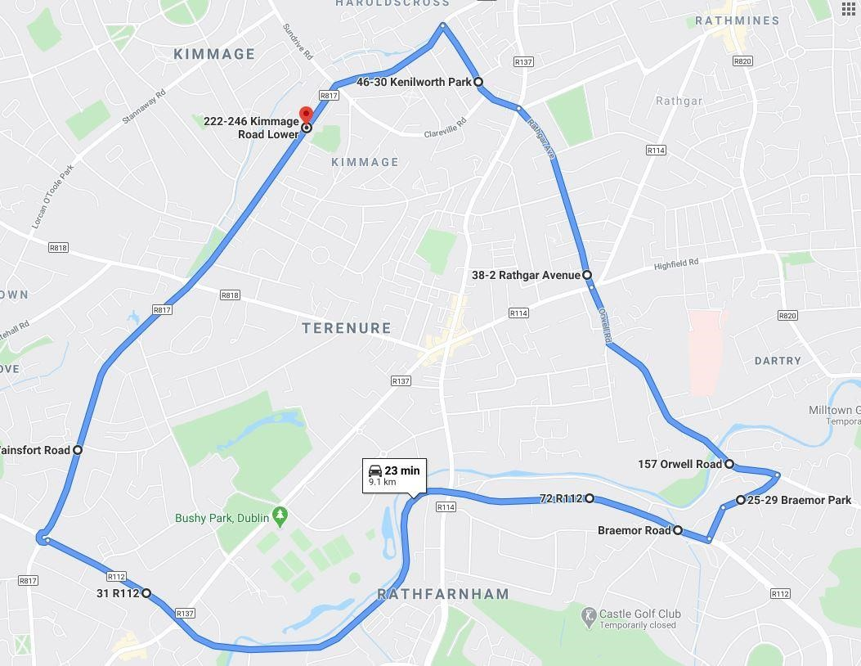

Boundary Map Top Half:

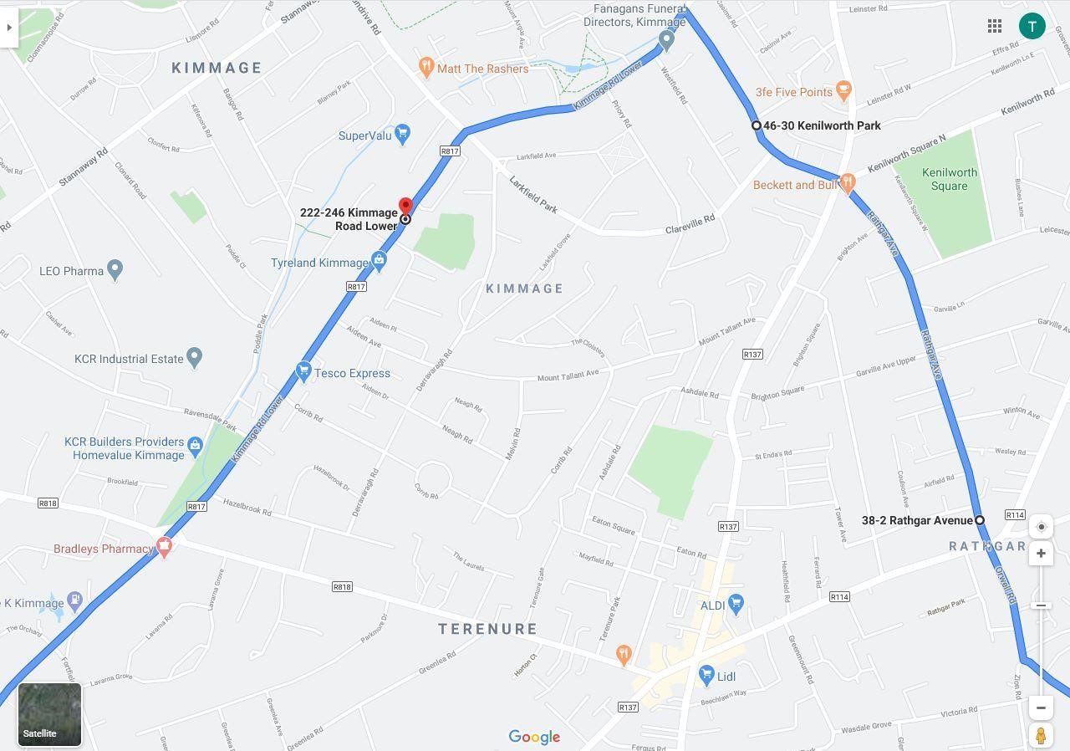

Boundary Map Bottom Left:

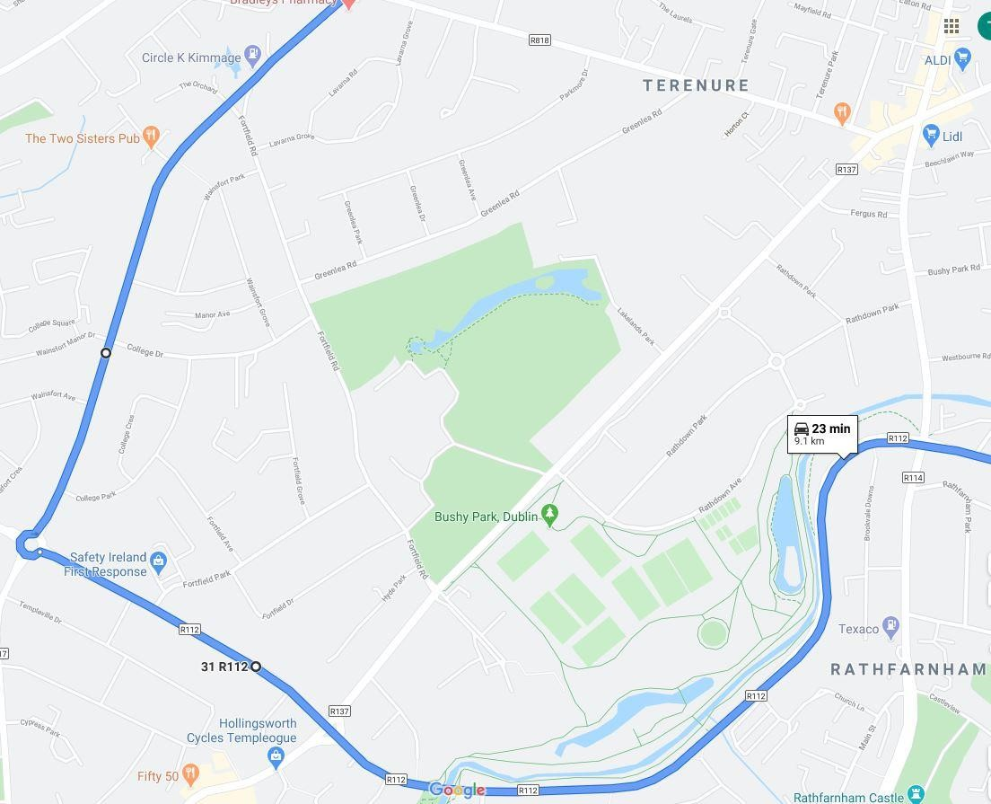Boundary Map Bottom Right:

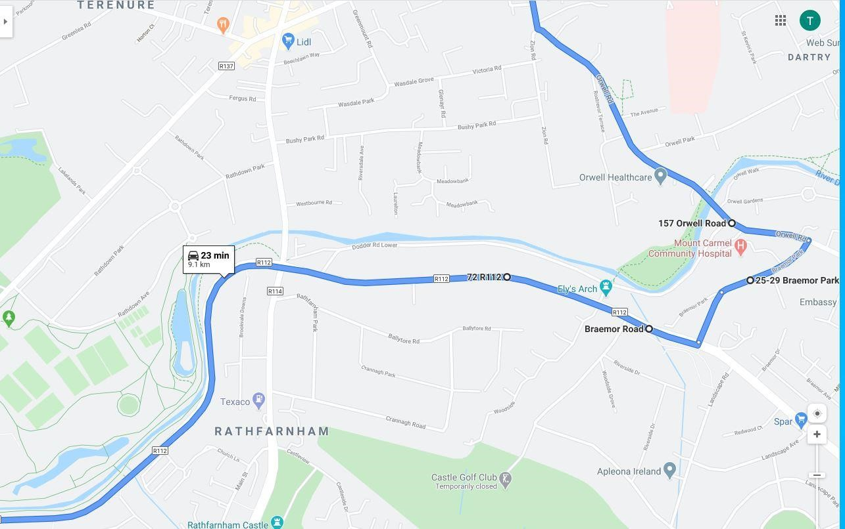

SECTION 7
APPLICATION TO THE SPECIAL CLASS

7.1. Admission Provisions for the Special Classes
7.1.1. Oversubscription
7.1.2. Selection criteria in order of priority
7.1.3. Selection process
7.1.4. Late Applications
7.1.5. Second/third-round offers of a place
7.1.6. Acceptance of a place
7.1.7. Refusal
7.1.8. Withdrawal of an offer

7.2. Appeals
7.2.1. Appeal where refusal was due to oversubscription
7.2.2. Appeal where refusal was for a reason other than oversubscription
7.2.3. Basis for a review by the Board of Management

7.1. ADMISSION PROVISIONS FOR THE SPECIAL CLASSES
Presentation Community College has two special classes established to provide education to Students with severe/complex educational needs arising from Autism/Autistic Spectrum Disorders.
Only applications in respect of Students whose needs fall within the category of special educational needs provided for by the Special Class will be considered.
In this respect, the school requires that such severe/complex educational and the related diagnosis of the Student be evidenced and verified in a Relevant Report, the mandatory elements of which are set out in the Glossary of Terms section, and which has been prepared within the 24 months immediately preceding the Student’s application to the Special Class, unless the application is for first year and the Student is already enrolled in a special class in primary school at the time of application, in which case the relevant report does not need to be dated within 24 months of the application. The school also requires documentation from the NCSE (National Council for Special Education) confirming that the student is known to the NCSE and has the required diagnosis and recommendation for a special class, in addition to a relevant report.
In the event that the special class in Presentation Community College is not oversubscribed, all Students whose needs fall within the category of special educational needs provided for by the Special Class and who submit the Requisite Report together with the documentation from the NCSE, will be offered a place in the Special Class, subject to sections 4.7 and 4.8.
Incomplete applications received by the school will not be processed under this policy.

7.1.1 Oversubscription
When the number of applications exceeds the number of places available, the published selection criteria as set out at section 7.1.2 below will apply and a waiting list shall be compiled which shall remain valid only for the school year in respect of which the applications are made. Where Presentation Community College is in a position to offer further places that become available in the Special Class for and during that academic year, places will be offered in accordance with the order of priority in which Students have been placed on the waiting list, subject to their being a place in the relevant mainstream year group. If there is not a place available in the relevant year group the next person on the waiting list for the Special Class will be considered for the place in question but this will not change the initial Student’s place on the waiting list for the Special Class for the remainder of that school year, i.e. if another place subsequently became available in the Special Class during that school year, the initial Student at the top of the waiting list would be considered first, but again subject to their being a place in the relevant year group for that Student.
For clarity, if a place becomes available in a given mainstream class group, before that place is offered to a Student on the waiting list for that mainstream year group, the waiting list for the Special Class shall be reviewed and if there is a place available in the Special Class and there is a Student on the waiting list who would be able to take up the place due to the available place in the given mainstream year group, that student will be offered the place in the Special Class (thereby removing the place in the mainstream year group). This is in the interest of ensuring that the scarce resources of the Special Class are never underutilised.

Where an application is made on behalf of a Student for both the Special Class and a mainstream year group, and his/her application for one but not both is successful, s/he will remain in the same position on the waiting list for the group to which s/he was not successful, regardless of whether the Applicant accepts the place in the group to which the Student was successful.
For the avoidance of doubt, if a Student does not receive a place in the Special Class for a given academic year, but s/he wishes to be considered for admission to the Special Class in the following academic year, a new application must be made on behalf of that Student during the dates specified by the school as being the period when it will accept applications for the Special Class.
Where the school is oversubscribed, any selection criteria that are not included in this Admission Policy shall not be considered in determining whether or not a Student is admitted to the school.

7.1.2 Selection criteria in order of priority
Applications to the Special Class will only be considered if the Student’s needs fall within the specified category of special educational needs provided for by this class. Subject to this requirement, in the event of oversubscription, the following criteria for admission to the Special Class will apply:

      - If the Student will have attained at least 12 years of age by 31st January of the academic year to which s/he is applying to be enrolled in the Special Class and lives within the Catchment area;

      - If the Student will have attained at least 12 years of age by 31st January of the academic year to which s/he is applying to be enrolled in the Special Class and currently has siblings enrolled in Presentation Community College (at time of application);

      - If the Student will have attained at least 12 years of age by 31st January of the academic year to which s/he is applying to be enrolled in the Special Class and had attended one of the feeder schools (in order of priority);

Presentation Primary School, Terenure, Dublin, 6W
St. Joseph’s Boys Primary School, Terenure, Dublin, 6
Harolds Cross Primary School, Dublin, 6W

7.1.2.4 If the Student will have attained at least 12 years of age by 31st January of the academic year to which s/he is applying to be enrolled in the Special Class and has the greatest level of need, as determined by the Principal in consultation with the SEN team in the school, having considered the Relevant Report in respect of the Child; if two or more Students are tied on this criterion then the next selection criteria in the list will be applied to those students to determine the order of priority of those students.

7.1.2.5 If the Student will have attained at least 12 years of age by 31st January of the academic year to which s/he is applying to be enrolled in the Special Class and if a parent or guardian of the Student is a member of staff of the school;

7.1.2.6 Other Applicants who will have attained at least 12 years of age by 31st January of the academic year to which s/he is applying to be enrolled in the Special Class.

7.1.3 Selection Process
Presentation Community College will apply the selection process as follows:
Having met the criteria for admission to the Special Class, applications are considered against the published selection criteria. Places will be offered in the first instance to those who meet the first criterion. Subsequently, where the Special Class still has places available the remaining Applicants are considered against the second criterion and those Applicants who meet this criterion will be offered a place within the Special Class. This process is continuously carried out against all selection criteria until all available places have been offered and accepted.
Where two or more applications are tied in the foregoing selection process, Presentation Community College, will apply a random lottery to assign any available places in the Special Class, or on the waiting list, to those applications.
N.B. The number of places available in a year group is subject to reduction in the event that a placement(s) in the Special Class is/are given to Student(s) from that year group, i.e. the selection process for the Special Class will be completed before the selection process for the mainstream year group and the number of Students who are offered a place in the Special Class will be the number by which the places in the relevant mainstream year group(s) are reduced.

7.1.4 Late applications
An application received by Presentation Community College after the closing date published by Presentation Community College, and set out in the Admission Notice, is considered a late application for the purposes of this Admission Policy.
Where the Special Class is oversubscribed and receives a late application for admission, that application will receive a place on the waiting list beneath Applicants whose applications were received by the school before the closing date for applications, irrespective of any selection criteria which may have been applied to applications received before the closing date for applications. Such late applications will be placed on the waiting list in accordance with the date and time they were received by the school, subject to sections 4.7 and 4.8. For the avoidance of doubt, selection criteria are not relevant to, and will not be applied to, late applications.

Where the Special Class is not oversubscribed, i.e. there is no waiting list, and it receives a late application, the Student seeking admission will receive an offer of a place in the Special Class subject to sections 4.7 and 4.8. and the same process as applies to Applicants whose applications were received before the closing date will be applied i.e. an Acceptance Form will be issued to the Applicant for completion and return to the school within two weeks of issue.

7.1.5 Second/third round offers of a place
Where a Student is in receipt of an offer of a place within the Special Class but does not accept the offer, or the school withdraws the offer in line with the relevant provisions of this Policy, the place will be offered to the next Student on the waiting list in a second-round of offers. This process will continue throughout third and fourth rounds etc until all places within the Special Class have been filled.

7.1.6 Acceptance of a place
If the Student in respect of whom the application is made is offered a place, the Applicant will be issued with an Acceptance Form by the school.
The Applicant shall indicate acceptance of an offer by fully completing and returning the Acceptance Form by the date set out in the School Admission Notice, or within two weeks of issuing by the school if it is a late application or if it is a second/third-round offer. This includes indicating whether or not s/he has applied for and is awaiting confirmation of an offer of admission from another school.

Failure to fully complete and return the Acceptance Form to the school by the date set out in the school’s Admission Notice, or within two weeks of issuing by the school if it is a late application or if it is a second/third-round offer, may result in withdrawal of an offer, in line with the grounds for withdrawal of an offer, as set out below.

7.1.7 Refusal
Where a Student in respect of whom an application is being sought has not been offered a school place, the Applicant will be provided in writing with:

7.1.7.1 The reasons that the Student was not a offered a place in Presentation Community College;

7.1.7.2 Details of the Student’s ranking against the published selection criteria, if the year group to which the applicant is applying is oversubscribed;

7.1.7.3 Details of the Student’s place on the waiting list, if applicable; and

7.1.7.4 Details of the Applicant’s right to appeal the decision
In addition to the conditions for consideration of an application as set out at 4.7, 4.8 an offer of admission may not be made where:

7.1.7.5 The information contained in the application is false or misleading in a material respect.

7.1.8 Withdrawal of an offer
An offer of admission may be withdrawn where:

7.1.8.1 The information contained in the application is false or misleading in a material respect, or

7.1.8.2 The Applicant fails to confirm acceptance of an offer of admission on or before the date set out in the annual Admission Notice of the school for the academic year for which s/he is applying, or in the case of a late application, or second/third-round offer, within two weeks, or

7.1.8.3 An Applicant has not indicated:
- whether or not s/he has applied for and is awaiting confirmation of an offer from another school(s) and if so, the details of the school(s);
and
- whether or not s/he has accepted an offer of admission from another school(s) and if so, the details of the offer(s).

If an offer of a place is withdrawn by the school, the Student on whose behalf the application was made shall lose his/her place for that academic year (and shall not be placed on a waiting list). If the Applicant still desires a place for that academic year, a new application must be made for same academic year on behalf of that Student and shall be treated as a late application in line with section 7.1.4 above.

APPEALS

7.2.1 Appeal where refusal was due to oversubscription:

An Applicant who was refused admission because the school is oversubscribed and who wishes to appeal this decision must first request a review by the Board of Management in writing, via a ‘BOMR1 Form’, available from the school office and at https://www.gov.ie/en/publication/8248c-appeals-in-relation-to-refusal-to-admit-a-student-due-to-a-school-being-oversubscribed/#how-to-seek-a-review-by-the-board-of-management, for it to be reviewed by the Board of Management of Presentation Community College. Such a review must be sought by the Applicant twenty-one calendar days of the school’s decision to refuse to admit. However, if a different time period for the bringing of such an appeal is specified by the Minister for Education after the publication of this Policy, same shall apply instead. Completed BOMR1 Forms should be submitted to the school office by emailing info@pcc.cdetb.ie

If an Applicant is not satisfied with the decision of the Board of Management, or the Board of Management is not in a position to review the decision to refuse admission, the Applicant may apply to bring an appeal to an Appeals Committee established by the Minister for Education under section 29A of the Education Act 1998. Appeals must be made in writing on a ‘Section 29 Appeal Form’ available at https://www.gov.ie/en/publication/8248c-appeals-in-relation-to-refusal-to-admit-a-student-due-to-a-school-being-oversubscribed/#how-to-appeal-if-a-child-has-been-refused-admission-because-the-school-is-full and submitted to the Section 29 Appeals Administration Unit in the Department of Education or the appeal can be submitted online by uploading the required documentation at https://www.section29appeals.gov.ie/. As per the Department of Education’s ‘Procedures for hearing and determining appeals under section 29’’, such an appeal must not be brought until the Applicant has received correspondence from the Board of Management in relation to the review, or until 42 calendar days have passed since the date of initial refusal, whichever is earlier, and the appeal may not be brought later than 63 calendar days after the initial decision to refuse admission.

7.2.2. Appeal where refusal was for a reason other than oversubscription:
An Applicant who was refused admission to Presentation Community College for a reason other than the school being oversubscribed and who wishes to appeal this decision may first choose to request a review by the Board of Management, via a BOMR1 Form, available from the school office and at https://www.gov.ie/en/publication/31c4f-appeals-in-relation-to-refusal-to-admit-a-student-for-a-reason-other-than-the-school-being-oversubscribed/#how-to-seek-a-review-by-the-board-of-management, for it to be reviewed by the board of management of Presentation Community College. Such a review must be sought by the Applicant within twenty-one calendar days of the school’s decision to refuse to admit. However, if a different time period for the bringing of such an appeal is specified by the Minister for Education after the publication of this Policy, same shall apply instead. Completed BOMR1 Forms should be submitted to the school office or emailed to info@pcc.cdetb.ie. (An applicant may withdraw a request for review at any time prior to the conclusion of the review by notifying the board of management in writing to that effect).
Alternatively, s/he may choose to apply to bring an appeal to an Appeals Committee established by the Minister for Education under section 29A of the Education Act 1998. Appeals must be made in writing on a ‘Section 29 Appeal Form’ available at https://www.gov.ie/en/publication/31c4f-appeals-in-relation-to-refusal-to-admit-a-student-for-a-reason-other-than-the-school-being-oversubscribed/#how-to-appeal-if-my-child-has-been-refused-admission-and-the-school-has-places-available and submitted to the Section 29 Appeals Administration Unit in the Department of Education or the appeal can be submitted online by uploading the required documentation at https://www.section29appeals.gov.ie/. As per the Department of Education’s ‘Procedures for hearing and determining appeals under section 29’, such an appeal may not be brought later than 63 calendar days after the initial decision to refuse admission.

If an Applicant who seeks a review by the Board of Management is not satisfied with the decision of the Board of Management, that Applicant may also apply to bring an appeal to an Appeals Committee established by the Minister for Education under section 29A of the Education Act 1998, as outlined in the immediately preceding paragraph.

7.2.3 Basis for a review by the Board of Management:
As required by section 29C(2) of the Education Act 1998, any request for the Board of Management to review a decision of the school to refuse admission must be based on the implementation of this Admission Policy, the content of the school’s Admission Notice and also set out the grounds of the request to review the decision.

