HOW TO ACCESS GOOGLE CLASSROOM
Google Classroom is an app linked to a student’s school email account
The format for all accounts is
firstname.surname@student.presentationcollege.ie
Each student has their own individual password

How to Access Google Classroom
Students are reminded they must use Safari Private (on Apple Devices) or Incognito (on Android Devices) in order to access either their emails or Google Classroom
Do not download the app onto your ipad or device.
If students wish they may log into their school email account and access through the apps
or through http://classroom.google.com and sign in with your school account.

There is a link to this on the school website: presentationcollege.ie
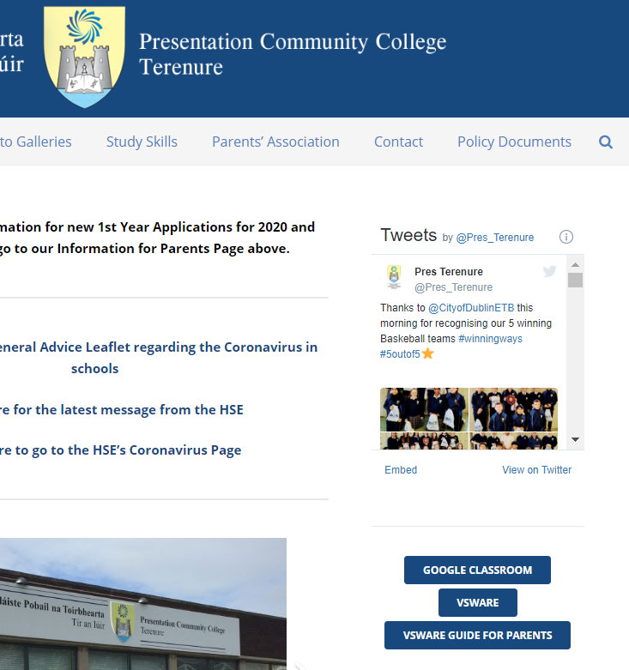

When you access Google Classroom you will have access to the Classrooms for different subjects- this is where teachers will post homework or tasks for students to complete.
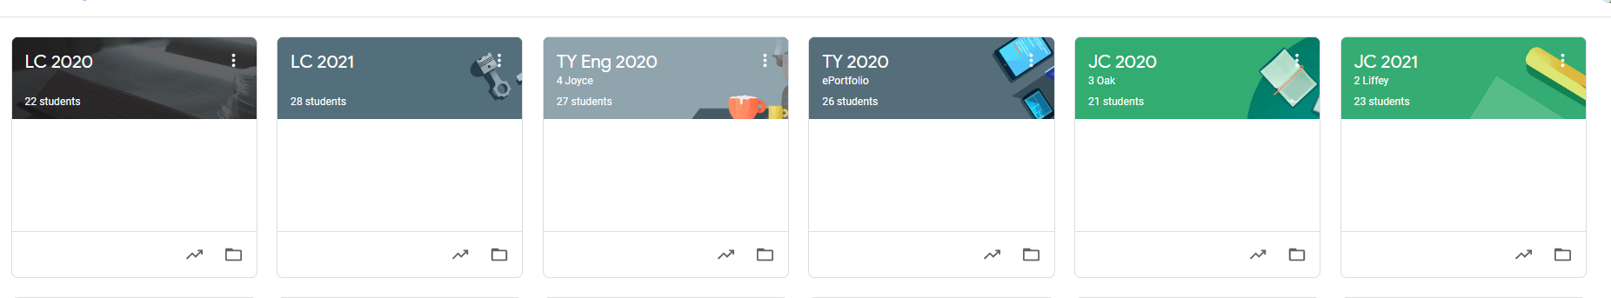
If a student is not logged into a particular subject’s Google Classroom or does not have the code, they must check their email account – teachers can send links to these that will appear in your account. Alternatively, the student can email the teacher directly.

There is a facility to post comments on these sites. Students are reminded these are accessed and visible by the teacher. Students are encouraged to use this facility in an appropriate manner.

Should a student have any issues accessing a school gmail account; parents can email Ms Harkin – aharkin@presentationcollege.ie

