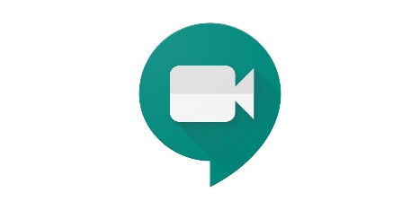
Online Classes Using Google Hangout
Teachers will be organising online classes with you using the Google App – Google Hangout (Meet & Chat)

This app will make use of the microphone and camera on your device.
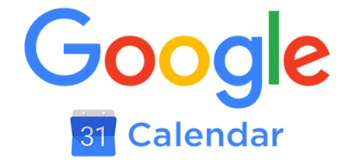

They will be scheduling these classes through Google Calendar

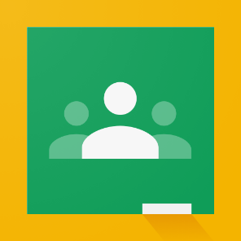
If you click into your calendar on Google Classroom you should be able to see these classes
Once they have scheduled them they will post the link on their Google Classroom. You will be able to access their online class by clicking the link they have posted in their Google Classroom.

Please click into the link approx. 4 minutes before the class is due to start to ensure you are ready when the class begins.
Click on Join when this screen appears
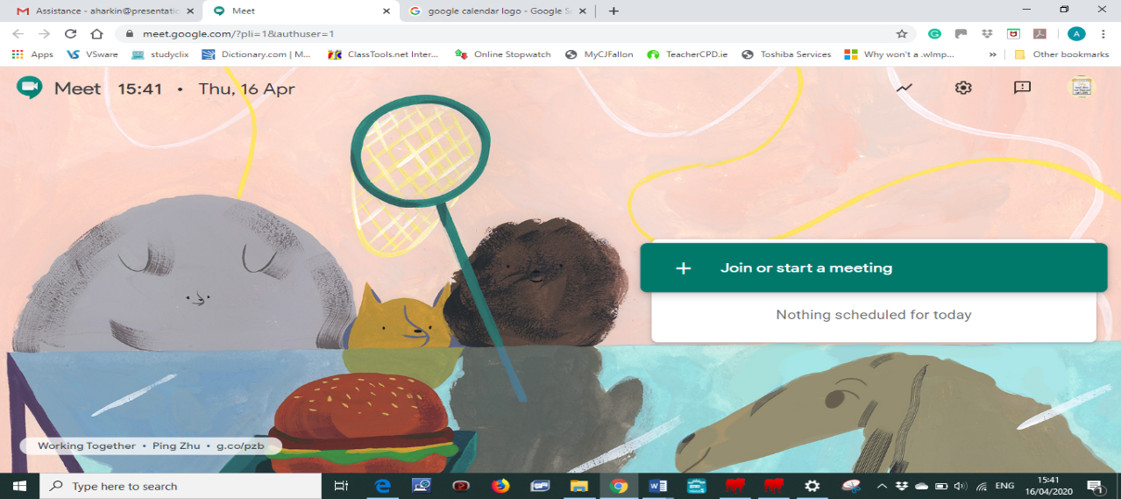

The app uses your devices camera & microphone so you should be able to see and hear the teacher – this app does not allow you to see everyone simultaneously but it does allow you to hear everyone. The personal speaking will appear in the main section of screen, with others tiled along the edge.
During the Class:
PLEASE MUTE YOUR MICROPHONE – otherwise the background sounds and noises from everyone is distracting.
There is also a chat function – this will allow you to ask questions or indicate to the teacher you wish to speak. Please don’t speak until the teacher calls on you, as they will mute themselves to ensure you are clearly heard by the entire class.

Click on the Chat Function – this will allow you to type questions or indicate to the teacher you wish to speak
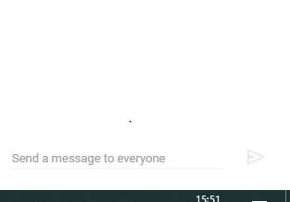
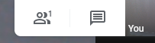

Click on the arrow to send the question –everyone present will be able to see the questions/comments.

If you click your screen this appears,

You can turn on the captions (subtitles) for the meeting if you are having trouble hearing. But these can be quite distracting. Instead, it would be a good idea to use headphones as it will help with hearing clearly.
If you click on present now, you can show the teacher and class a document or webpage that you have open on your screen
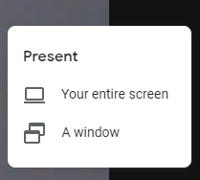
Click on Your entire screen

This window will appear then click on this screen and then the share button
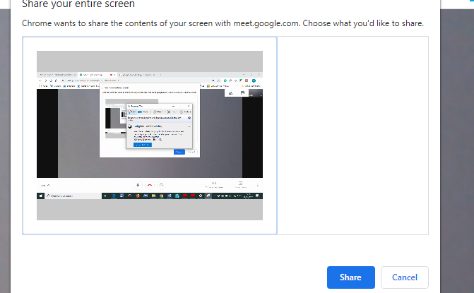

Your screen will then be visible to all members of the class – as you click on your documents etc they will appear on every else’s screen.

This will also be true if your teacher wants to show you material they will present your screen.

