HOW TO ATTACH PHOTOS TO EMAILS
During this school closures, some students have been writing the work set by the teachers. This work should then be photographed and emailed to the teacher for correction.
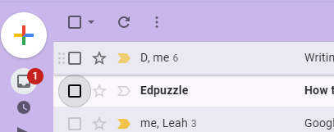
Once the photos are taken, students should open their school email account.
Click on the plus sign on the left – if you are using a laptop or ipad

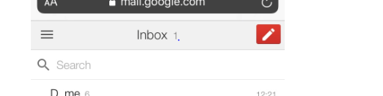
Click on the pen if you are using a phone

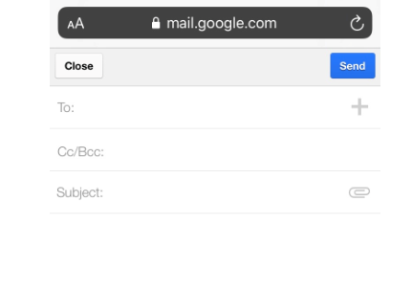
A new email will open – please type the teacher’s email address in the section called To
Write your message in the box

How to attach the photos – click on the paper clip icon

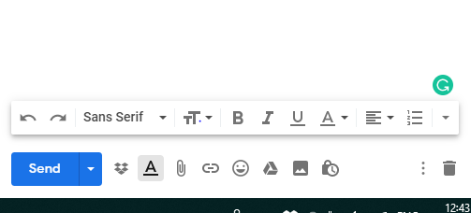

How to attach the photos – click on the paper clip icon

On your phone, once you click on the icon it will open, it will ask you what you want to attach – click attach file
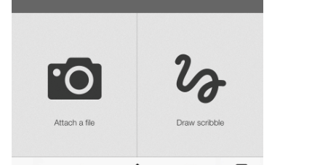
then it will take you to your photo library
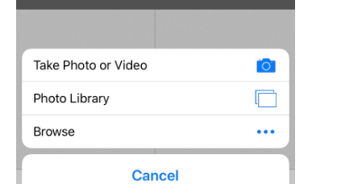

On you laptop, once you have clicked on the paperclip icon the following should open which will allow you to click on pictures and attach anything you have saved in this folder.
